CSS Assignment

1. Build a Responsive Pricing Table

• Use Flexbox or CSS Grid for layout.

• Each plan should be in a card format with listed features.

• Highlight the “Pro” plan with a different background and hover scale animation.

• Use media queries to make it stack vertically on smaller screens.

<!DOCTYPE html>

<html lang="en">

<head>

  <meta charset="UTF-8" />

  <meta name="viewport" content="width=device-width, initial-scale=1" />

  <title>Responsive Pricing Table</title>

  <style>

    body {

      font-family: Arial, sans-serif;

      background: #f7f7f7;

      margin: 20px;

      padding: 0;

      display: flex;

      justify-content: center;

    }

    .pricing-table {

      display: flex;

      gap: 20px;

      max-width: 900px;

      width: 100%;

      flex-wrap: wrap;

    }

    .plan {

      background: white;

      border-radius: 10px;

      box-shadow: 0 2px 8px rgba(0,0,0,0.1);

      flex: 1 1 250px;

      padding: 20px;

      text-align: center;

      transition: transform 0.3s ease;

      display: flex;

      flex-direction: column;

      justify-content: space-between;

    }

    .plan:hover {

      transform: scale(1.05);

      cursor: pointer;

    }

    .plan.pro {

      background: #007bff;

      color: white;

      transform-origin: center;

    }

    .plan.pro:hover {

      transform: scale(1.1);

      box-shadow: 0 4px 15px rgba(0,123,255,0.6);

    }

    .plan h2 {

      margin-top: 0;

    }

    .price {

      font-size: 2.5em;

      margin: 10px 0;

    }

    ul.features {

      list-style: none;

      padding: 0;

      margin: 20px 0;

      flex-grow: 1;

      text-align: left;

    }

    ul.features li {

      margin-bottom: 10px;

      padding-left: 20px;

      position: relative;

    }

    ul.features li::before {

      content: "✓";

      position: absolute;

      left: 0;

      color: #28a745;

      font-weight: bold;

    }

    .btn {

      background: #007bff;

      color: white;

      padding: 12px;

      border: none;

      border-radius: 5px;

      font-weight: bold;

      text-transform: uppercase;

      transition: background 0.3s ease;

      cursor: pointer;

      margin-top: auto;

    }

    .plan.pro .btn {

      background: white;

      color: #007bff;

    }

    .plan.pro .btn:hover {

      background: #0056b3;

      color: white;

    }

    @media (max-width: 700px) {

      .pricing-table {

        flex-direction: column;

        align-items: center;

      }

      .plan {

        max-width: 300px;

        width: 100%;

      }

    }

  </style>

</head>

<body>

  <div class="pricing-table">

    <div class="plan basic">

      <h2>Basic</h2>

      <div class="price">$9<span>/mo</span></div>

      <ul class="features">

        <li>10 Projects</li>

        <li>5 GB Storage</li>

        <li>Email Support</li>

        <li>Basic Analytics</li>

      </ul>

      <button class="btn">Choose Basic</button>

    </div>

    <div class="plan pro">

      <h2>Pro</h2>

      <div class="price">$29<span>/mo</span></div>

      <ul class="features">

        <li>Unlimited Projects</li>

        <li>50 GB Storage</li>

        <li>Priority Email Support</li>

        <li>Advanced Analytics</li>

      </ul>

      <button class="btn">Choose Pro</button>

    </div>

    <div class="plan enterprise">

      <h2>Enterprise</h2>

      <div class="price">$99<span>/mo</span></div>

      <ul class="features">

        <li>Unlimited Projects</li>

        <li>Unlimited Storage</li>

        <li>24/7 Support</li>

        <li>Custom Analytics</li>

      </ul>

      <button class="btn">Choose Enterprise</button>

    </div>

  </div>

</body>

</html>

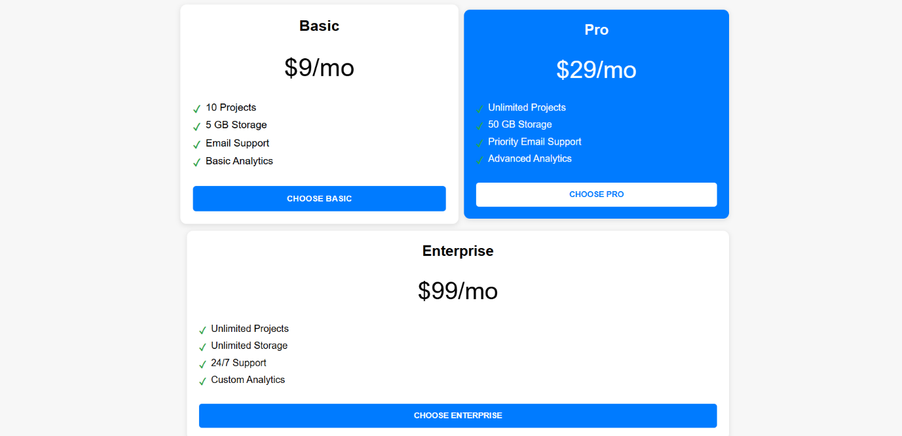

2. Create a CSS-Based Image Gallery

• Use a grid layout to display images.

• On hover, images should zoom and show a caption using ::after or ::before.

• Adjust to single-column layout on mobile.

<!DOCTYPE html>

<html lang="en">

<head>

  <meta charset="UTF-8" />

  <meta name="viewport" content="width=device-width, initial-scale=1" />

  <title>CSS Image Gallery</title>

  <style>

    body {

      font-family: Arial, sans-serif;

      margin: 20px;

      background: #f4f4f4;

    }

    .gallery {

      display: grid;

      grid-template-columns: repeat(auto-fit, minmax(200px, 1fr));

      gap: 15px;

      max-width: 900px;

      margin: 0 auto;

    }

    .gallery-item {

      position: relative;

      overflow: hidden;

      cursor: pointer;

      border-radius: 8px;

      box-shadow: 0 2px 6px rgba(0,0,0,0.1);

    }

    .gallery-item img {

      width: 100%;

      height: auto;

      display: block;

      transition: transform 0.4s ease;

      border-radius: 8px;

    }

    .gallery-item:hover img {

      transform: scale(1.1);

    }

    .gallery-item::after {

      content: attr(data-caption);

      position: absolute;

      bottom: 0;

      left: 0;

      right: 0;

      background: rgba(0,0,0,0.6);

      color: #fff;

      padding: 10px;

      font-size: 1rem;

      opacity: 0;

      transition: opacity 0.4s ease;

      border-bottom-left-radius: 8px;

      border-bottom-right-radius: 8px;

      text-align: center;

    }

    .gallery-item:hover::after {

      opacity: 1;

    }

    @media (max-width: 500px) {

      .gallery {

        grid-template-columns: 1fr;

      }

    }

  </style>

</head>

<body>

  <h1 style="text-align:center;">CSS Image Gallery</h1>

  <div class="gallery">

    <div class="gallery-item" data-caption="Beautiful Mountain">

      <img src="https://picsum.photos/id/1018/400/300" alt="Mountain" />

    </div>

    <div class="gallery-item" data-caption="Calm Lake">

      <img src="https://picsum.photos/id/1015/400/300" alt="Lake" />

    </div>

    <div class="gallery-item" data-caption="City Skyline">

      <img src="https://picsum.photos/id/1011/400/300" alt="City" />

    </div>

    <div class="gallery-item" data-caption="Forest Path">

      <img src="https://picsum.photos/id/1016/400/300" alt="Forest" />

    </div>

    <div class="gallery-item" data-caption="Sunset Beach">

      <img src="https://picsum.photos/id/1020/400/300" alt="Beach" />

    </div>

    <div class="gallery-item" data-caption="Snowy Mountains">

      <img src="https://picsum.photos/id/1003/400/300" alt="Snowy Mountains" />

    </div>

  </div>

</body>

</html>

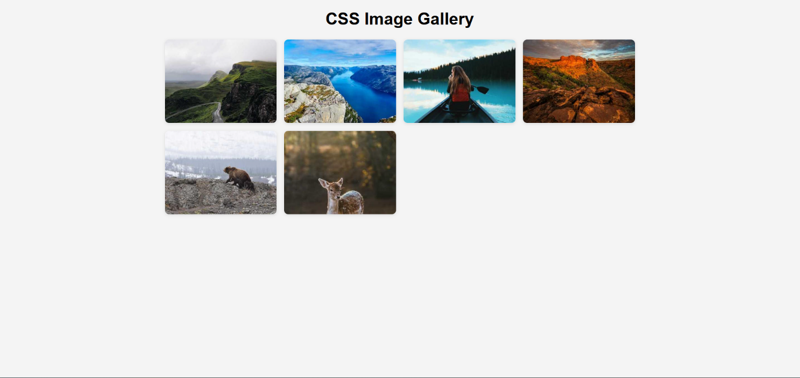

3. Design a Themed Landing Page

• Include navigation, hero, features, and footer sections.

• Use CSS variables for consistent color and spacing.

• Add scroll-based CSS transitions (like fade/slide in).

• Make it fully responsive.

<!DOCTYPE html>

<html lang="en">

<head>

  <meta charset="UTF-8" />

  <meta name="viewport" content="width=device-width, initial-scale=1" />

  <title>Themed Landing Page</title>

  <style>

    :root {

      --primary-color: #4a90e2;

      --secondary-color: #50e3c2;

      --text-color: #333;

      --background-color: #f9faff;

      --spacing: 1.5rem;

      --max-width: 1200px;

    }

    \* {

      box-sizing: border-box;

    }

    body {

      margin: 0;

      font-family: 'Segoe UI', Tahoma, Geneva, Verdana, sans-serif;

      color: var(--text-color);

      background-color: var(--background-color);

      scroll-behavior: smooth;

    }

    a {

      color: var(--primary-color);

      text-decoration: none;

    }

    .container {

      max-width: var(--max-width);

      margin: 0 auto;

      padding: 0 var(--spacing);

    }

    nav {

      background: white;

      box-shadow: 0 2px 6px rgba(0,0,0,0.1);

      position: sticky;

      top: 0;

      z-index: 100;

    }

    nav .container {

      display: flex;

      align-items: center;

      justify-content: space-between;

      height: 60px;

    }

    nav ul {

      list-style: none;

      display: flex;

      gap: var(--spacing);

      margin: 0;

      padding: 0;

    }

    nav ul li {

      padding: 0.5rem 1rem;

    }

    nav ul li a:hover {

      color: var(--secondary-color);

    }

    .hero {

      background: linear-gradient(135deg, var(--primary-color), var(--secondary-color));

      color: white;

      padding: 6rem 1rem;

      text-align: center;

      position: relative;

      overflow: hidden;

    }

    .hero h1 {

      font-size: 3rem;

      margin-bottom: 1rem;

    }

    .hero p {

      font-size: 1.2rem;

      max-width: 600px;

      margin: 0 auto 2rem;

      line-height: 1.5;

    }

    .btn-primary {

      background-color: white;

      color: var(--primary-color);

      padding: 1rem 2rem;

      border: none;

      border-radius: 30px;

      font-weight: 700;

      font-size: 1rem;

      cursor: pointer;

      transition: background-color 0.3s ease, color 0.3s ease;

    }

    .btn-primary:hover {

      background-color: var(--secondary-color);

      color: white;

    }

    .features {

      padding: 4rem 1rem;

      background: white;

      display: grid;

      grid-template-columns: repeat(auto-fit, minmax(280px, 1fr));

      gap: 2rem;

      max-width: var(--max-width);

      margin: 0 auto;

    }

    .feature {

      background: var(--background-color);

      padding: 2rem;

      border-radius: 10px;

      box-shadow: 0 4px 12px rgba(0,0,0,0.05);

      opacity: 0;

      transform: translateY(40px);

      transition: opacity 0.6s ease-out, transform 0.6s ease-out;

    }

    .feature.visible {

      opacity: 1;

      transform: translateY(0);

    }

    .feature h3 {

      margin-top: 0;

      margin-bottom: 1rem;

      color: var(--primary-color);

    }

    .feature p {

      margin: 0;

      line-height: 1.4;

    }

    footer {

      background: var(--primary-color);

      color: white;

      text-align: center;

      padding: 2rem 1rem;

      margin-top: 3rem;

    }

    @media (max-width: 600px) {

      .hero h1 {

        font-size: 2.2rem;

      }

      .hero p {

        font-size: 1rem;

      }

    }

  </style>

</head>

<body>

  <nav>

    <div class="container">

      <a href="#" class="logo"><strong>BrandName</strong></a>

      <ul>

        <li><a href="#hero">Home</a></li>

        <li><a href="#features">Features</a></li>

        <li><a href="#footer">Contact</a></li>

      </ul>

    </div>

  </nav>

  <section id="hero" class="hero">

    <h1>Welcome to Our Amazing Product</h1>

    <p>Discover the future of efficiency with our cutting-edge solutions designed to elevate your business.</p>

    <button class="btn-primary">Get Started</button>

  </section>

  <section id="features" class="features">

    <div class="feature">

      <h3>Fast Performance</h3>

      <p>Our product ensures blazing fast performance so you can work smarter, not harder.</p>

    </div>

    <div class="feature">

      <h3>Secure & Reliable</h3>

      <p>Top-tier security protocols keep your data safe and your mind at ease.</p>

    </div>

    <div class="feature">

      <h3>User Friendly</h3>

      <p>An intuitive interface that everyone can use without a steep learning curve.</p>

    </div>

    <div class="feature">

      <h3>24/7 Support</h3>

      <p>Our team is here for you around the clock to solve any problems quickly.</p>

    </div>

  </section>

  <footer id="footer">

    <p>&copy; 2025 BrandName. All rights reserved.</p>

  </footer>

  <script>

    // Scroll-based fade/slide-in animation

    const features = document.querySelectorAll('.feature');

    function checkVisibility() {

      const triggerBottom = window.innerHeight \* 0.85;

      features.forEach(feature => {

        const featureTop = feature.getBoundingClientRect().top;

        if (featureTop < triggerBottom) {

          feature.classList.add('visible');

        }

      });

    }

    window.addEventListener('scroll', checkVisibility);

    window.addEventListener('load', checkVisibility);

  </script>

</body>

</html>

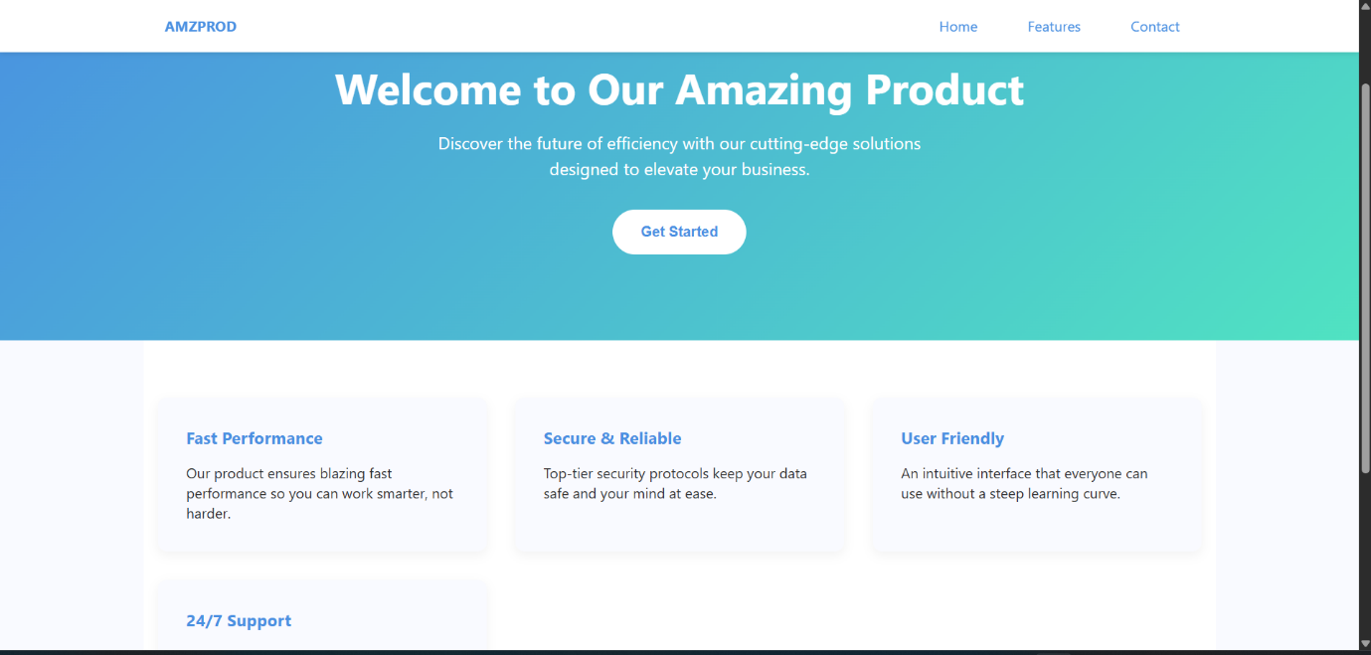

4. Build a Vertical Timeline Component

• Use pseudo-elements (::before, ::after) for connecting lines.

• Each event is a styled card with date and description.

• Hovering changes background or border style.

<!DOCTYPE html>

<html lang="en">

<head>

<meta charset="UTF-8" />

<meta name="viewport" content="width=device-width, initial-scale=1" />

<title>Vertical Timeline</title>

<style>

  body {

    font-family: Arial, sans-serif;

    background: #f7f9fc;

    margin: 40px;

    color: #333;

  }

  .timeline {

    position: relative;

    max-width: 600px;

    margin: 0 auto;

    padding-left: 40px;

  }

  /\* The vertical line \*/

  .timeline::before {

    content: "";

    position: absolute;

    top: 0;

    left: 18px;

    width: 4px;

    height: 100%;

    background: #4a90e2;

    border-radius: 2px;

  }

  /\* Each event card \*/

  .event {

    position: relative;

    background: white;

    border: 2px solid #ddd;

    border-radius: 8px;

    padding: 15px 20px 15px 30px;

    margin-bottom: 30px;

    transition: background-color 0.3s ease, border-color 0.3s ease;

  }

  /\* Circle marker \*/

  .event::before {

    content: "";

    position: absolute;

    left: -28px;

    top: 20px;

    width: 20px;

    height: 20px;

    background: white;

    border: 4px solid #4a90e2;

    border-radius: 50%;

    box-sizing: border-box;

  }

  /\* Date style \*/

  .event .date {

    font-weight: bold;

    font-size: 0.9rem;

    color: #4a90e2;

    margin-bottom: 8px;

  }

  /\* Description \*/

  .event .desc {

    font-size: 1rem;

    line-height: 1.4;

  }

  /\* Hover effect \*/

  .event:hover {

    background-color: #e6f0fa;

    border-color: #357ABD;

  }

  /\* Responsive \*/

  @media (max-width: 480px) {

    body {

      margin: 20px 10px;

    }

    .timeline {

      padding-left: 30px;

    }

    .event::before {

      left: -35px;

      top: 15px;

      width: 16px;

      height: 16px;

      border-width: 3px;

    }

  }

</style>

</head>

<body>

  <h2 style="text-align:center; margin-bottom: 40px;">Vertical Timeline</h2>

  <div class="timeline">

    <div class="event">

      <div class="date">January 2023</div>

      <div class="desc">Started learning web development with HTML, CSS, and JavaScript basics.</div>

    </div>

    <div class="event">

      <div class="date">March 2023</div>

      <div class="desc">Built first personal portfolio website and published it online.</div>

    </div>

    <div class="event">

      <div class="date">July 2023</div>

      <div class="desc">Completed a full-stack web development bootcamp.</div>

    </div>

    <div class="event">

      <div class="date">December 2023</div>

      <div class="desc">Started freelancing as a web developer and took on multiple client projects.</div>

    </div>

  </div>

</body>

</html>

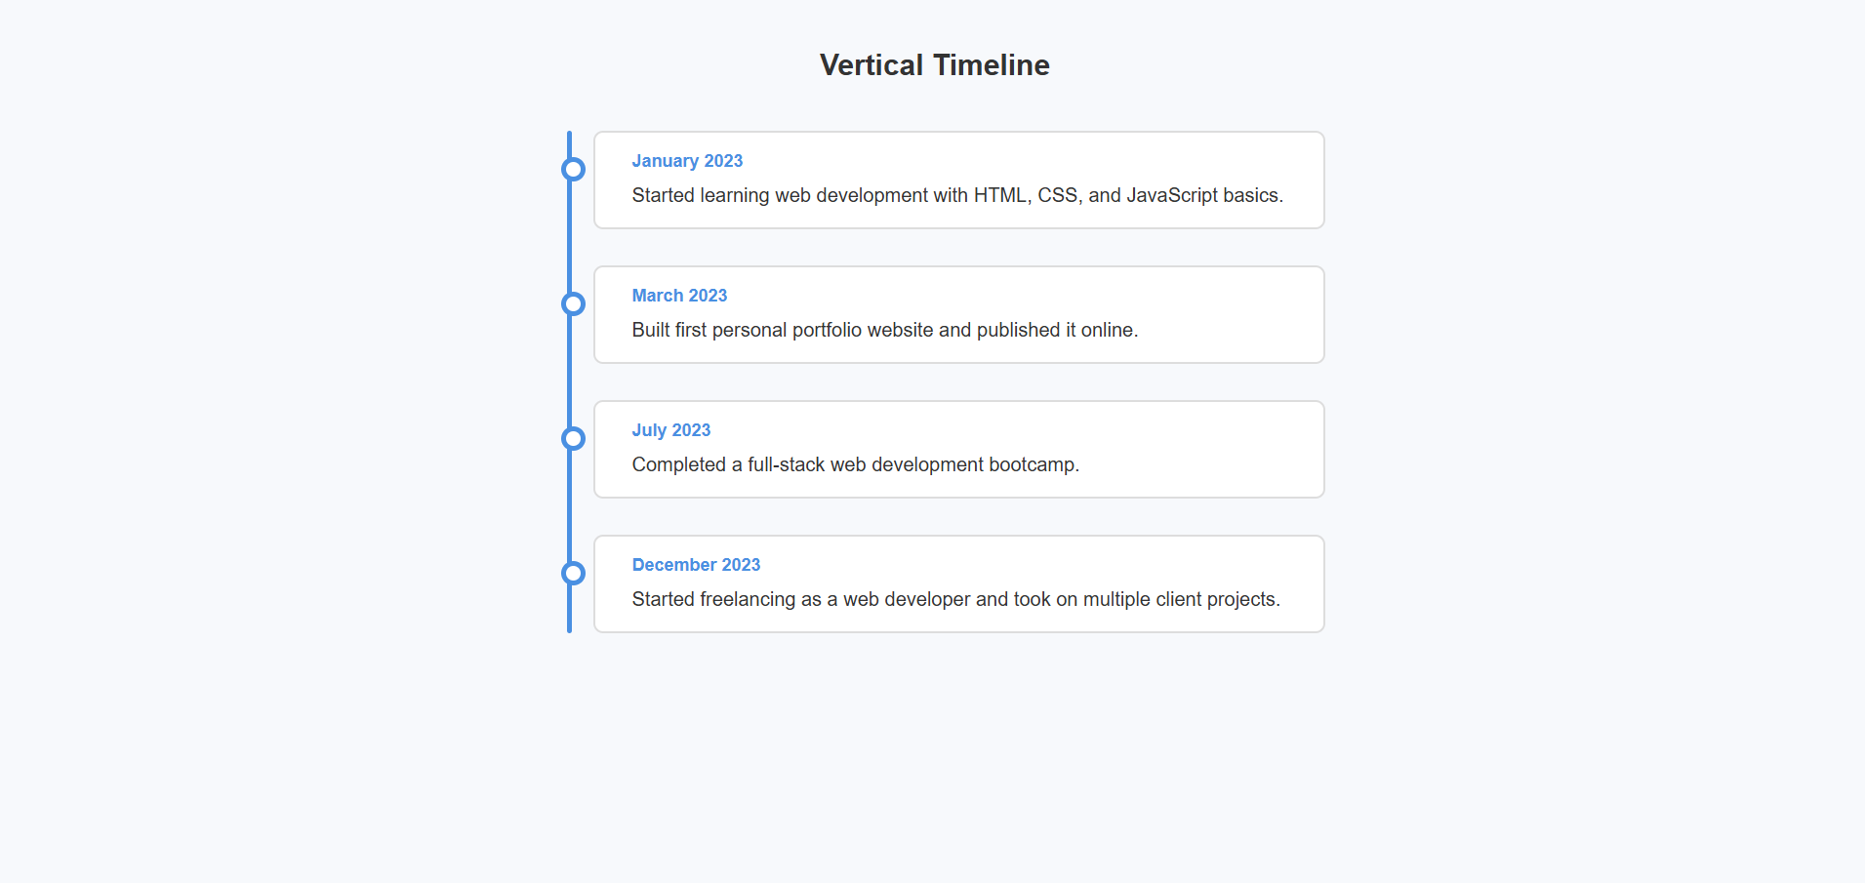

5. Implement a Tabbed Interface (Pure CSS)

• Use radio buttons or checkboxes to switch tabs.

• CSS selectors control tab content visibility.

• Add transitions for a smooth UX.

<!DOCTYPE html>

<html lang="en">

<head>

    <meta charset="UTF-8">

    <meta name="viewport" content="width=device-width, initial-scale=1.0">

    <title>Pure CSS Tabbed Interface</title>

    <style>

        body {

            font-family: 'Arial', sans-serif;

            line-height: 1.6;

            margin: 0;

            padding: 20px;

            background-color: #f5f5f5;

        }

        .tab-container {

            max-width: 800px;

            margin: 0 auto;

            background: white;

            box-shadow: 0 2px 10px rgba(0,0,0,0.1);

            border-radius: 8px;

            overflow: hidden;

        }

        .tabs {

            display: flex;

            list-style: none;

            margin: 0;

            padding: 0;

            background: #f0f0f0;

        }

        .tab {

            flex: 1;

            text-align: center;

        }

        .tab-label {

            display: block;

            padding: 15px;

            cursor: pointer;

            font-weight: bold;

            color: #555;

            transition: all 0.3s ease;

        }

        .tab-label:hover {

            background: #e0e0e0;

            color: #333;

        }

        .tab-radio {

            display: none;

        }

        .tab-content {

            display: none;

            padding: 20px;

            opacity: 0;

            transform: translateY(10px);

            transition: opacity 0.3s ease, transform 0.3s ease;

        }

        .tab-radio:checked + .tab-label {

            background: #4CAF50;

            color: white;

        }

        .tab-radio:checked ~ .tab-content {

            display: block;

            opacity: 1;

            transform: translateY(0);

        }

    </style>

</head>

<body>

    <div class="tab-container">

        <ul class="tabs">

            <li class="tab">

                <input type="radio" name="tabs" id="tab1" class="tab-radio" checked>

                <label for="tab1" class="tab-label">Home</label>

                <div class="tab-content">

                    <h2>Welcome Home</h2>

                    <p>This is the home section content. You can put anything you want here.</p>

                    <p>Lorem ipsum dolor sit amet, consectetur adipiscing elit. Nullam auctor, nisl eget ultricies tincidunt, nisl nisl aliquam nisl.</p>

                </div>

            </li>

            <li class="tab">

                <input type="radio" name="tabs" id="tab2" class="tab-radio">

                <label for="tab2" class="tab-label">About</label>

                <div class="tab-content">

                    <h2>About Us</h2>

                    <p>Learn more about our company and what we do.</p>

                    <p>Sed do eiusmod tempor incididunt ut labore et dolore magna aliqua. Ut enim ad minim veniam, quis nostrud exercitation ullamco laboris.</p>

                </div>

            </li>

            <li class="tab">

                <input type="radio" name="tabs" id="tab3" class="tab-radio">

                <label for="tab3" class="tab-label">Services</label>

                <div class="tab-content">

                    <h2>Our Services</h2>

                    <p>Here are the services we offer to our clients.</p>

                    <ul>

                        <li>Web Design</li>

                        <li>Graphic Design</li>

                        <li>SEO Optimization</li>

                    </ul>

                </div>

            </li>

            <li class="tab">

                <input type="radio" name="tabs" id="tab4" class="tab-radio">

                <label for="tab4" class="tab-label">Portfolio</label>

                <div class="tab-content">

                    <h2>Our Work</h2>

                    <p>Check out some of our recent projects.</p>

                    <div style="display: flex; gap: 10px;">

                        <div style="width: 100px; height: 100px; background: #ddd;"></div>

                        <div style="width: 100px; height: 100px; background: #ddd;"></div>

                        <div style="width: 100px; height: 100px; background: #ddd;"></div>

                    </div>

                </div>

            </li>

            <li class="tab">

                <input type="radio" name="tabs" id="tab5" class="tab-radio">

                <label for="tab5" class="tab-label">Contact</label>

                <div class="tab-content">

                    <h2>Get in Touch</h2>

                    <p>Feel free to contact us with any questions.</p>

                    <p>Email: info@example.com<br>Phone: (123) 456-7890</p>

                </div>

            </li>

        </ul>

    </div>

</body>

</html>

